Submission File

**(Download and Edit this File)**

**Name: Priyanka Killedar**

**Submission Date: 3 may 2021**

**Drive URL: https://drive.google.com/drive/folders/12GMv65UeVv5woBF766_Ial40Fw_UmlBv?usp=sharing**

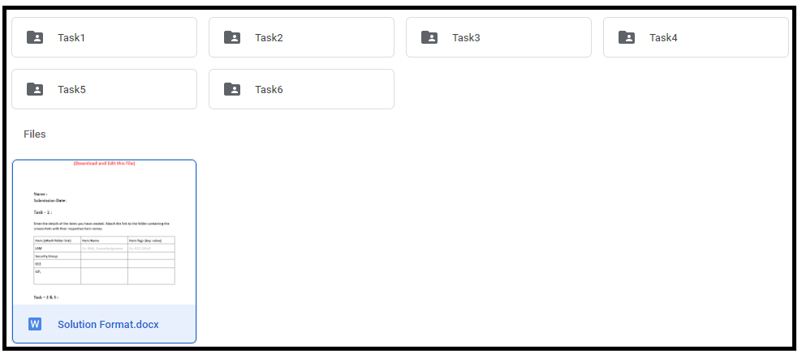

**Additional Comments:**

Facing issue while doing tas 5 and 6.SO not able to complete.So did not submit on 3rd May but in this week (3-10 may) not able to create services .Tried for the 3 -4 days and the page stuck at the tasks below for more than 2 hrs. It creates a listener for load balancer but is not able to create service. Tried multiple times.Not able to find IP for dig

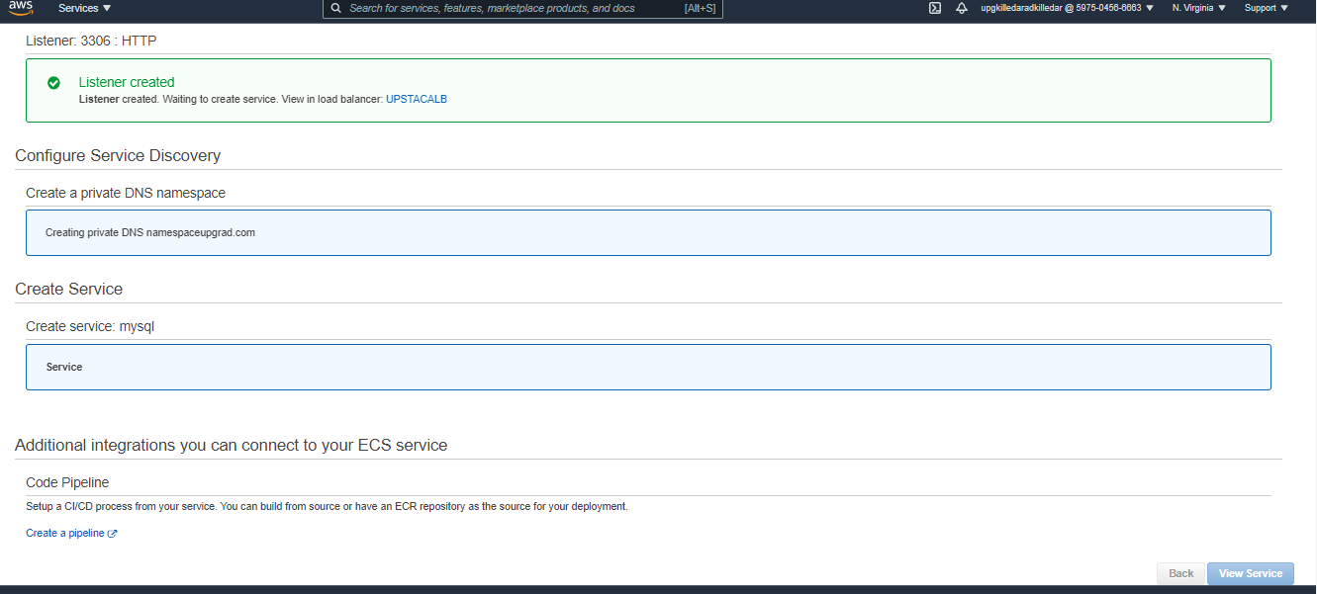

**Instructions for Learner:**

1. You are requested to follow the Drive Folder Structure for the submission.
2. It is utmost important that while capturing the screenshots be sure that all relevant information is captured. This will help grade your submission without any ambiguity.
3. In case you are looking to pass any explanation for grading your submission, do mention it as comments.